Application development

Deploy the given react application to a production ready state

Repo URL contain the react application : <https://github.com/sriram-R-krishnan/devops-build>

Github repository contains below files:

1. Dockerfile
2. docker-compose file
3. build.sh – building docker image
4. deploy.sh – to deploy image
5. .dockerignore – specifies which files and directories should be excluded from building
6. .getignore – specifies which files and directories should ignore in a repository
7. Jenkins file – contains a code to build dev and main branch based on the condition provided

URL : https://github.com/ramyaPandian1/capstone-devops-build

Deployed site URL: <http://13.58.211.155:80/>

Docker images name

dev repo : ramyaashwin/dev

main repo : ramyaashwin/main

SCREENSHOTS

1. Jenkins

* Used multibranch pipeline to build main and dev branch
* Created Jenkins file which will
  + Login to docker hub – for this created token in docker hub and added in Jenkins configuration
  + If the code is pushed to dev then dev build will run in that build the docker image is pushed to dev repository (public) in docker hub
  + If the dev is merged then docker image is pushed to main repository ( private) in docker hub and also ./deploy.sh will run so that application is deployed

**LOGIN PAGE**

Jenkins URL : <http://13.58.211.155:8080/>

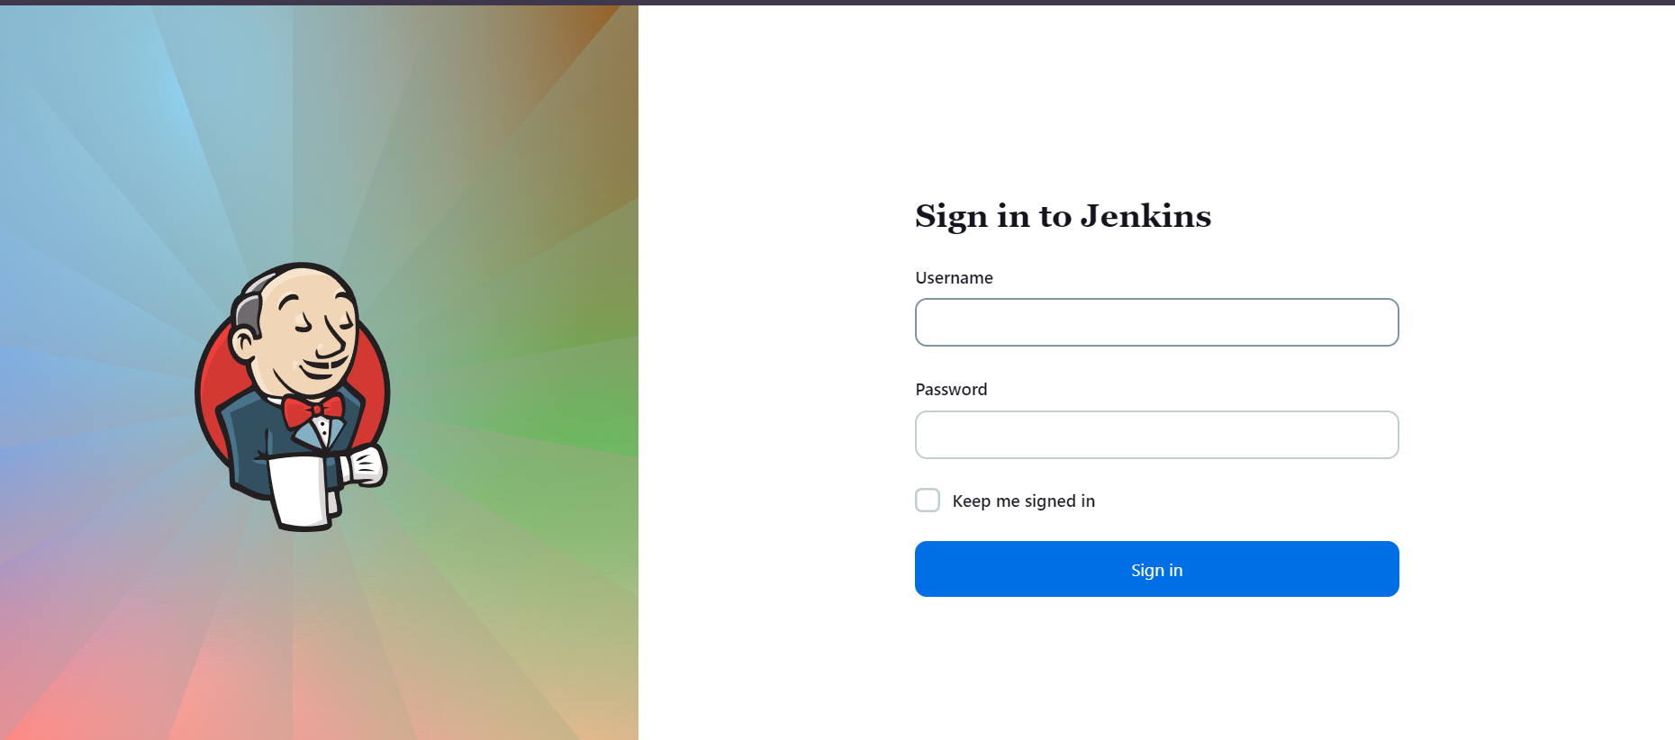

**CONFIGURATION SETTINGS**

1. Credentials :  
   added dockerhub credentials to use in Jenkins file
2. **Multibranch pipeline**

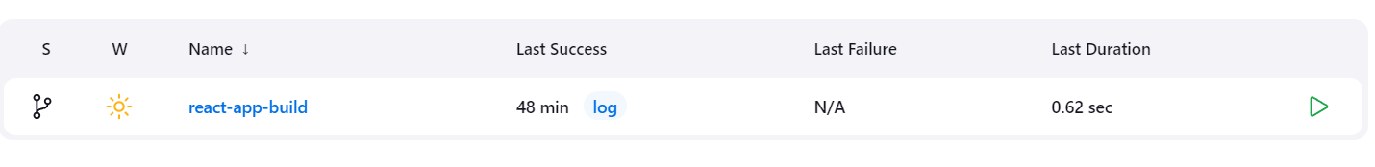

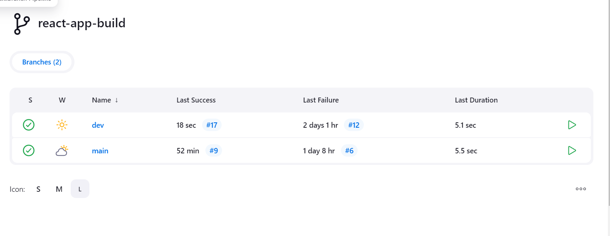

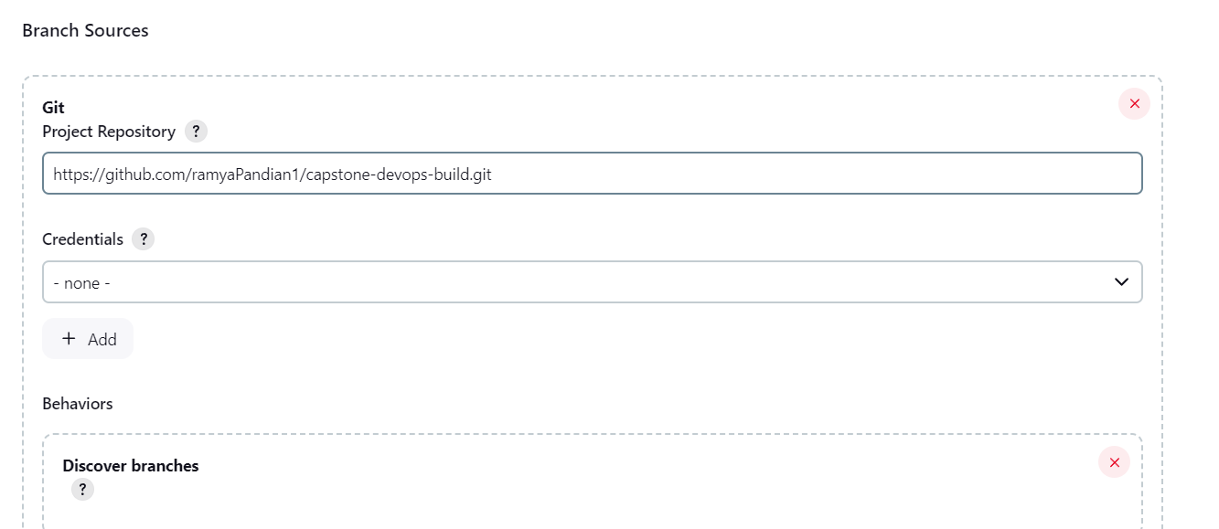

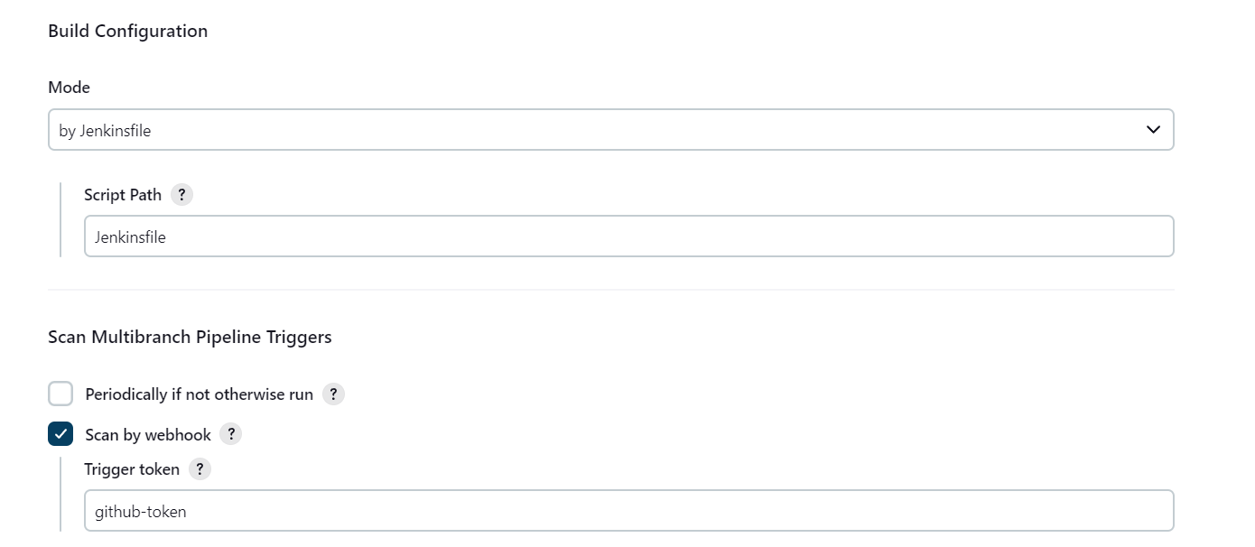

* Used githubwebhook trigger to integrate git and Jenkins
* Commands are passed in Jenkinsfile

**AWS**

1. EC2 console

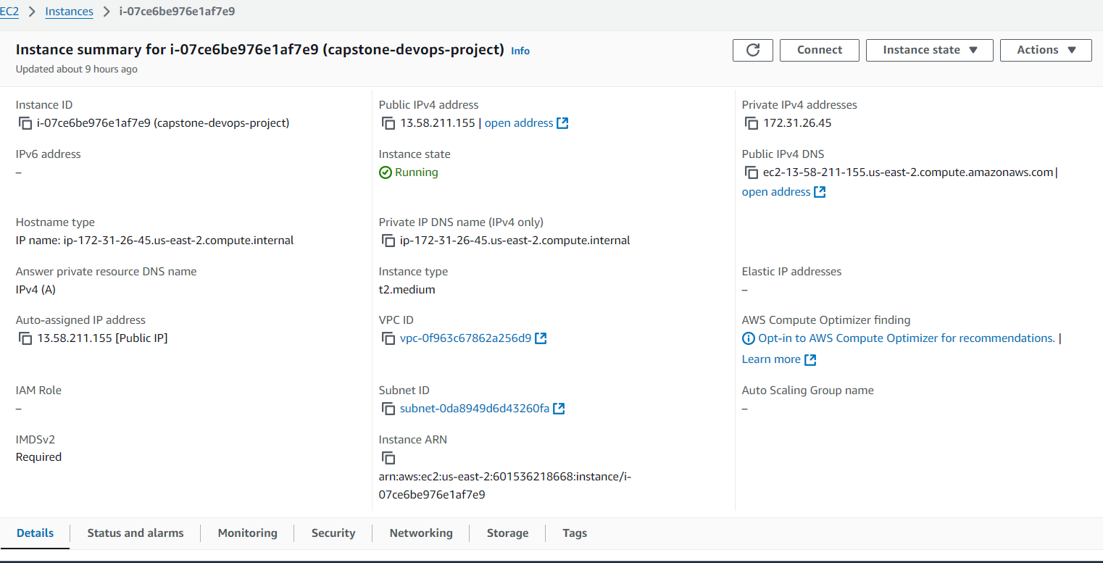

1. SG configs

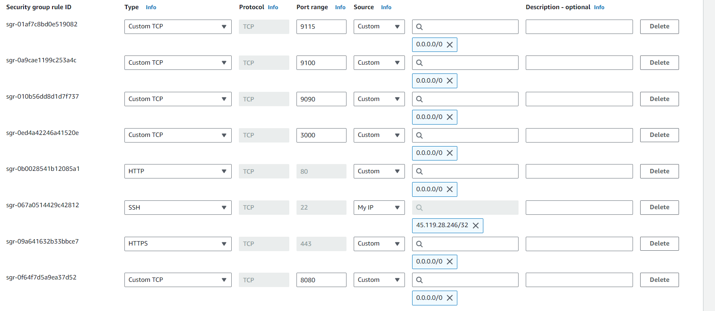

**DOCKERHUB**

* Main repo

Tag : latest

Image name: ramyaashwin/main

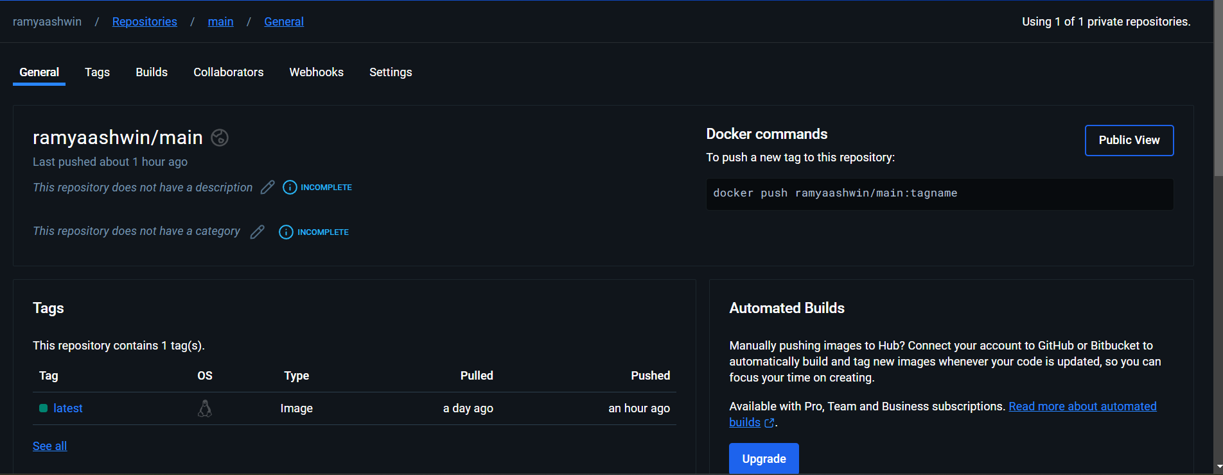

* **Dev repo:**

Tag: latest

Image name: ramyaashwin/dev

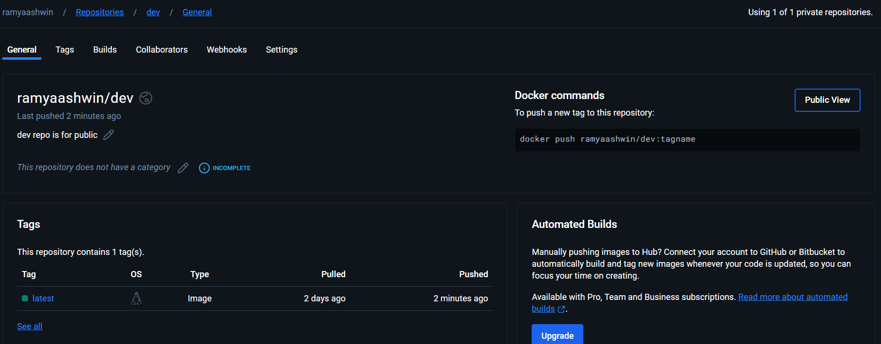

**Deployed Site page**

URL: <http://13.58.211.155:80/>



**Monitoring tool**

* Used Prometheus and Grafana for monitoring
* Prometheus URL: <http://13.58.211.155:9090/>
* Grafana URL: <http://13.58.211.155:3000/>

Prometheus query to check job is in running state

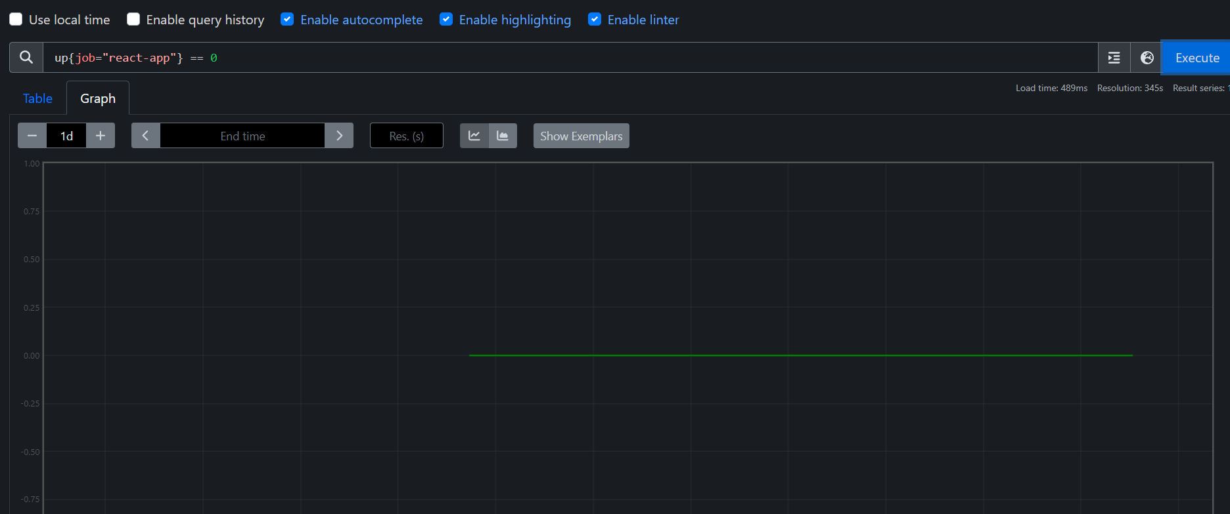

To monitor CPU usage

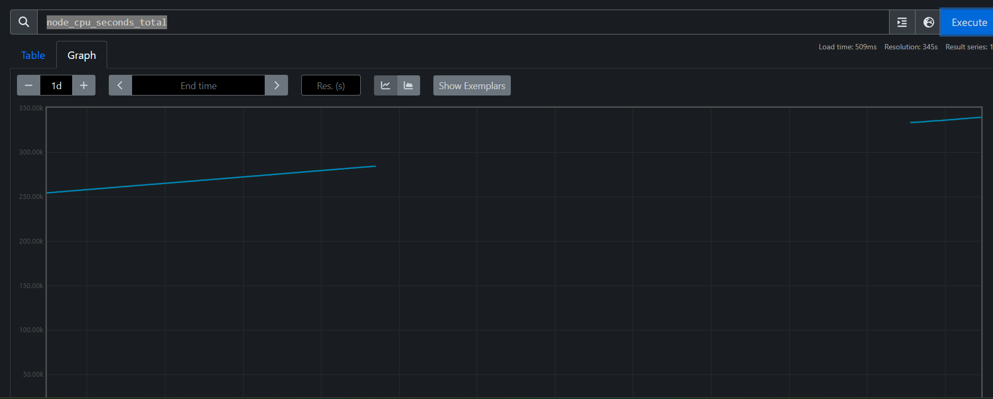

**Grafana :**

Dashboard

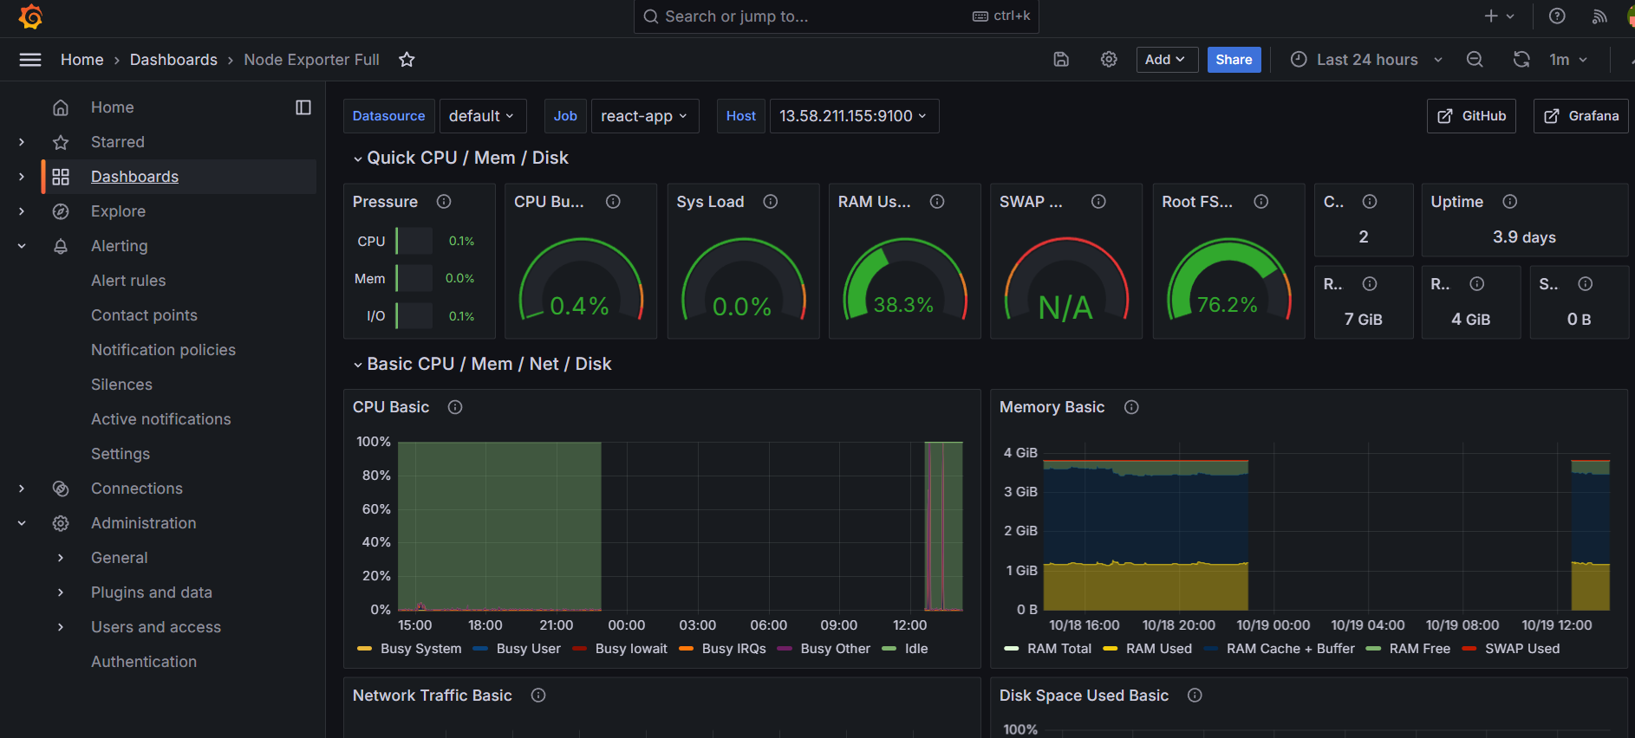

**For email notification**

1. Created a rule to alert in email when the application is down

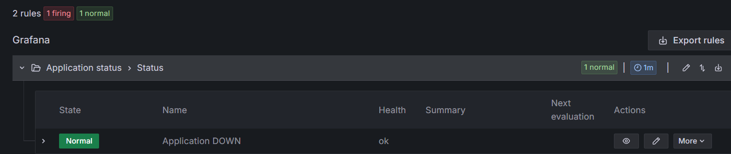

Unable to make application down Since I want to test the email configuration is correct or not checked with CPU usage and it worked fine

1.created an alert rule for CPU usage more than 50 percent

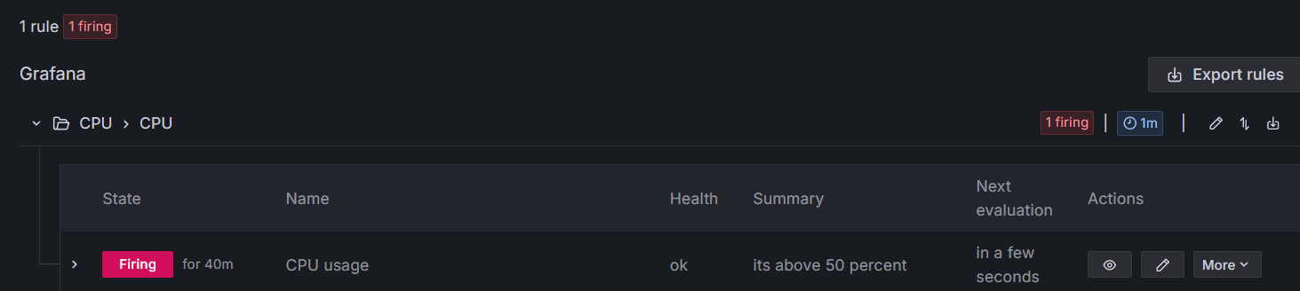

Email is triggered when its above 50 percent

